* Basic instruction (following)
* More tailed instructions apparently from a ZOOM website: <https://support.zoom.us/hc/en-us/articles/201362473-Local-recording>

**Video Instructions for Pre-recorded Talks**

**Video Specifications**

* The video should show the speaker presenting the slides, as if presenting them live.
* The recording should **show the slides in full-screen mode**, with webcam footage of the speaker in the top right corner (see below for how to record such a video with Zoom).
* Please be sure to introduce yourself and your project at the beginning of the video.
* All videos should be within the time limit, specific to the category of your specific award type.
* MP4 file format
* Clear audio (headsets are permitted)
* For the file name, use [event_name_number]_[LASTTNAME]_[firstname]_sgsma2021.mp4 (e.g. Webinar4_WILLIAMS_roger_sgsma2021.mp4)

**General Recording Tips**

1. Please ensure that the webcam inset of your own face does not obstruct any part of your slides.  For example, if you place it at the top right, ensure that it doesn’t cover parts of the slide titles.
2. Ensure your surroundings have no disruptive background noise.
3. Turn off any alerts on your computer, phone, etc. (e.g., use do-not-disturb mode).
4. Avoid using a noisy keyboard, especially if the space-bar makes a distinct clicking sound.  If you can’t use a quieter keyboard, use keys other than the space-bar (e.g., right or down arrow key); or advance your slides using the mouse.
5. Finally, review your video to ensure the audio is clear.

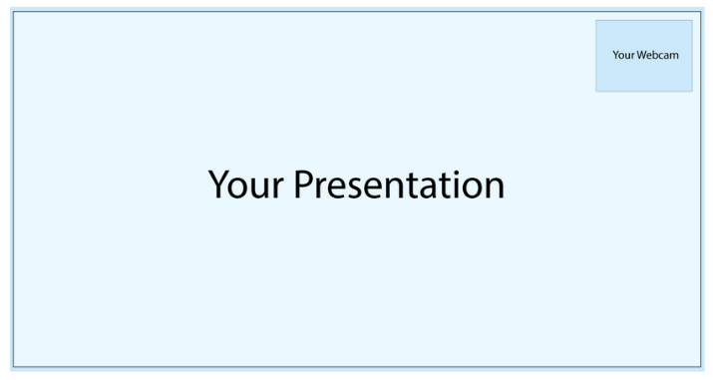

**Recording Your Talk with Zoom**

Authors may use any video conferencing software that is able to record a picture-in-picture screen-shared presentation featuring the slides and an inserts of the speaker. For example, here are the instructions for recording your presentation using Zoom:

1. Open the Zoom desktop application and select **New Meeting**.
2. Select **Join with computer audio** if prompted. We suggest using headphones or a headset equipped with a microphone for high quality audio.
3. **Be sure you are unmuted.**
4. Open your presentation and maximize it so that it is in full-screen mode.
5. Click on the green **Share Screen** button on the bottom Zoom toolbar.
6. Select the screen containing your presentation. Leave "Share computer sound" and "Optimize Screen Share for Video Clip" unchecked. Click **Share**.
7. Your webcam video will automatically place itself in the top right hand corner. We ask that you please click through your presentation slides with your webcam video window in the top right corner to ensure that your webcam footage does not cover any pertinent information on your slides. If so, we ask that you please edit your slides with the top right hand video footage box in mind.
8. Hover your mouse over the "You are screen sharing" green bar so that the menu bar above appears. Select **More**.
9. When you are ready to record your presentation, select **Record** from the dropdown menu. Choose "Record on this computer".
10. When you have finished recording, hover your mouse over the "You are screen sharing" green bar so the menu appears again. Select **More**.
11. From the drop down menu, select **Stop recording**. You may also **Pause recording** if you are not finished and resume when you are ready.
12. Your video will export once your meeting has ended. Select **Stop Share** to end your screen share.
13. Select **End>End Meeting For All** in the bottom right corner of your Zoom meeting.
14. Your video will now automatically convert, and your computer may prompt you for access to the Documents folder to save your video. Click **OK**.
15. Your video is now saved to your computer in the Documents folder. Be sure to review the footage of your presentation for any technical issues such as lapses in audio or lost webcam or slide footage.
16. Finally, upload the .mp4 file below.

We may contact you with questions or additional edits upon our review.